EWMA correlation: AUDUSD and EURGBP
Method 06 / daily log returns / lambda = 0.94 / Alpari D1 full available history

Study setup
Logical pair: AUDUSD , EURGBP
Broker symbols: AUDUSD_i , EURGBP_i
Snapshot: 2026-11-03_majors_alpari_D1
Timeframe: D1
Matched return window: 1999-01-06 to 2026-11-02 (UTC bar dates)
Matched return count n: 7198
Dropped unfinished last bar dated 2026-11-03 UTC after a tick-volume check against the prior complete day.
Lambda: 0.94 (today weight 0.06)
Burn-in ignored in path summaries and chart: first 60 updates
Mean adjustment: each leg demeaned by its mean on the matched rows
Seeds: c_0 = v_x,0 = v_y,0 = 0
Complete matched rows (Excel): AUDUSD-EURGBP_EWMA_D1.xlsx
Complete matched rows (HTML table): AUDUSD-EURGBP_EWMA_D1_data.html

Method carried forward
EWMA correlation updates covariance and variances of mean-adjusted daily log returns of close, ln(close_t / close_t-1), with lambda = 0.94 (6% weight on today's product or square, 94% on yesterday's EWMA state). Quotes are not inverted. Each leg is demeaned by its mean on the matched rows; that mean uses the full sample, so the rho path is a full-sample description, not a live filter. Seeds start at zero. Path summaries and the chart ignore the first 60 updates so the zero seed has faded. The headline is rho on the last day. rho is symmetric under swap of the two symbols. A high |rho| does not prove cause, lead-lag, or a trading signal. Today's return sits inside today's rho, so the estimate can only inform a later decision. Same-sample Pearson r is a side check only.

Results
Latest EWMA rho: -0.104554
Post-burn-in path (n=7138): mean=0.044263, median=0.044288, min=-0.812823, max=0.740804, std=0.264445
Share of post-burn-in days with |rho| >= 0.4: 15.77%; |rho| >= 0.7: 0.35%
Same-sample Pearson r: 0.038173
Latest rho minus r: -0.142727

Conclusion
Over 7198 matched daily log-return rows for AUDUSD and EURGBP (broker quote directions unchanged), latest EWMA rho with lambda=0.94 is -0.1046 (negative, weak recent linear link in this sample). After a 60-day burn-in, path mean is 0.0443, std is 0.2644, and the range is [-0.8128, 0.7408]. Same-sample Pearson r is 0.0382 (latest rho minus r = -0.1427). This does not establish cause, lead-lag, or a lasting trading rule.

Charts
Daily closes

Daily log returns
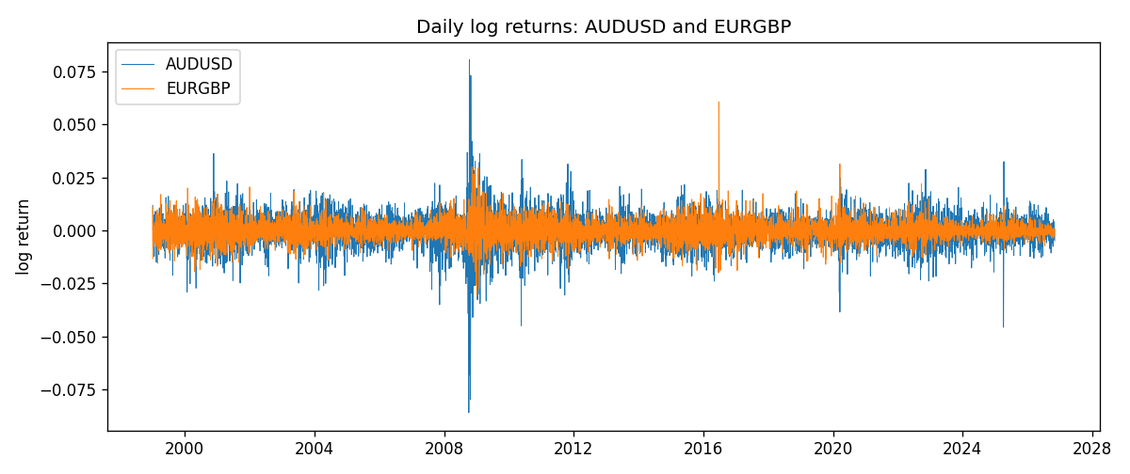
EWMA rho path with Pearson r reference
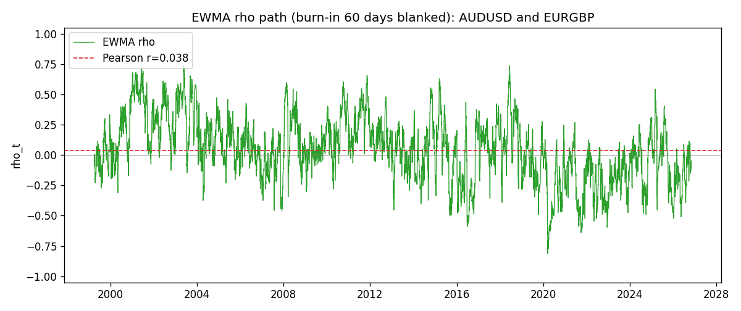

Data report
Every matched row that entered the EWMA recursion is stored in the sibling Excel workbook named AUDUSD-EURGBP_EWMA_D1.xlsx. That file is the complete data archive for redrawing charts. Embedding all rows as a Word table is impractical at this length; the Word file holds the column list, column summaries, and the first and last 15 matched rows.
Columns: time, AUDUSD_open, EURGBP_open, AUDUSD_high, EURGBP_high, AUDUSD_low, EURGBP_low, AUDUSD_close, EURGBP_close, AUDUSD_tick_volume, EURGBP_tick_volume, AUDUSD_spread, EURGBP_spread, AUDUSD_real_volume, EURGBP_real_volume, AUDUSD_log_return, EURGBP_log_return, AUDUSD_x_demeaned, EURGBP_y_demeaned, c_t, v_x, v_y, rho_t
Column summaries (matched calculation rows)
column | count | mean | std | min | 25% | 50% | 75% | max
AUDUSD_open | 7198 | 0.75202191 | 0.13526259 | 0.4785 | 0.6611175 | 0.731685 | 0.8091425 | 1.10284
EURGBP_open | 7198 | 0.78667202 | 0.09675257 | 0.5734 | 0.687325 | 0.83369 | 0.8651775 | 0.9769
AUDUSD_high | 7198 | 0.7560731 | 0.13582215 | 0.4878 | 0.6648025 | 0.7351 | 0.8153975 | 1.10795
EURGBP_high | 7198 | 0.7897492 | 0.09712763 | 0.5789 | 0.6894 | 0.836595 | 0.86804 | 0.9799
AUDUSD_low | 7198 | 0.74796393 | 0.1345766 | 0.4775 | 0.6578225 | 0.727775 | 0.804275 | 1.0975
EURGBP_low | 7198 | 0.7839722 | 0.09657024 | 0.5682 | 0.6853 | 0.831475 | 0.8627775 | 0.9661
AUDUSD_close | 7198 | 0.75206897 | 0.13524509 | 0.4786 | 0.661255 | 0.7318 | 0.8092725 | 1.10169
EURGBP_close | 7198 | 0.78671595 | 0.09675201 | 0.5735 | 0.687525 | 0.83375 | 0.865285 | 0.977
AUDUSD_tick_volume | 7198 | 77378.184 | 138156.24 | 109 | 5445.75 | 43349.5 | 71356.75 | 1234623
EURGBP_tick_volume | 7198 | 86961.088 | 145396.59 | 332 | 6520.25 | 44270 | 81329 | 1424684
AUDUSD_spread | 7198 | 30.809114 | 16.88495 | 0 | 13 | 30 | 50 | 50
EURGBP_spread | 7198 | 21.389692 | 19.14164 | 0 | 4 | 13 | 50 | 50
AUDUSD_real_volume | 7198 | 5.2442754e+09 | 1.2540657e+11 | 0 | 0 | 0 | 0 | 3.811512e+12
EURGBP_real_volume | 7198 | 2.7809077e+10 | 1.3507993e+11 | 0 | 0 | 0 | 0 | 3.5726265e+12
AUDUSD_log_return | 7198 | 2.054e-05 | 0.00754782 | -0.08602525 | -0.00386556 | 0.00027727 | 0.00415374 | 0.0806166
EURGBP_log_return | 7198 | 2.199e-05 | 0.00487197 | -0.03067367 | -0.00262256 | -0.00010006 | 0.00256155 | 0.06075387
AUDUSD_x_demeaned | 7198 | -0 | 0.00754782 | -0.08604579 | -0.0038861 | 0.00025673 | 0.0041332 | 0.08059606
EURGBP_y_demeaned | 7198 | -0 | 0.00487197 | -0.03069566 | -0.00264455 | -0.00012205 | 0.00253956 | 0.06073188
c_t | 7198 | 1.4e-06 | 1.269e-05 | -0.00011958 | -2.62e-06 | 8.8e-07 | 6.12e-06 | 5.586e-05
v_x | 7198 | 5.693e-05 | 0.00010021 | 8.25e-06 | 2.625e-05 | 3.685e-05 | 5.891e-05 | 0.00173308
v_y | 7198 | 2.373e-05 | 2.335e-05 | 1.89e-06 | 1.053e-05 | 1.824e-05 | 3.009e-05 | 0.00029342
rho_t | 7198 | 0.04237676 | 0.26453986 | -1 | -0.12646602 | 0.04249224 | 0.2101078 | 0.74080422
First 15 matched rows (selected columns)
time | AUDUSD_close | EURGBP_close | AUDUSD_log_return | EURGBP_log_return | AUDUSD_x_demeaned | EURGBP_y_demeaned | c_t | v_x | v_y | rho_t
1999-01-06 | 0.6289 | 0.7019 | 0.011836351 | -0.013303338 | 0.01181581 | -0.013325325 | -9.4469704e-06 | 8.3768021e-06 | 1.0653857e-05 | -1
1999-01-07 | 0.6345 | 0.7097 | 0.0088650256 | 0.011051402 | 0.0088444851 | 0.011029415 | -3.0271824e-06 | 1.2567689e-05 | 1.7313505e-05 | -0.20521938
1999-01-08 | 0.6347 | 0.7062 | 0.00031515916 | -0.004943862 | 0.00029461868 | -0.0049658488 | -2.9333333e-06 | 1.1818836e-05 | 1.7754274e-05 | -0.20249887
1999-01-11 | 0.6393 | 0.7053 | 0.0072213815 | -0.0012752393 | 0.007200841 | -0.001297226 | -3.3178004e-06 | 1.4220832e-05 | 1.6789985e-05 | -0.2147151
1999-01-12 | 0.6362 | 0.7077 | -0.0048608485 | 0.0033970309 | -0.0048813889 | 0.0033750441 | -4.1072266e-06 | 1.479726e-05 | 1.6466042e-05 | -0.26312579
1999-01-13 | 0.6312 | 0.708 | -0.0078902098 | 0.00042381861 | -0.0079107503 | 0.00040183186 | -4.0515205e-06 | 1.7664222e-05 | 1.5487767e-05 | -0.24494939
1999-01-14 | 0.6295 | 0.7066 | -0.002696916 | -0.0019793588 | -0.0027174565 | -0.0020013455 | -3.4821151e-06 | 1.7047443e-05 | 1.4798824e-05 | -0.21922995
1999-01-15 | 0.634 | 0.7012 | 0.007123101 | -0.0076715819 | 0.0071025605 | -0.0076935686 | -6.5518304e-06 | 1.9051379e-05 | 1.7462355e-05 | -0.35920969
1999-01-18 | 0.6346 | 0.7017 | 0.00094592471 | 0.00071280921 | 0.00092538423 | 0.00069082246 | -6.120364e-06 | 1.7959676e-05 | 1.6443248e-05 | -0.35615103
1999-01-19 | 0.6392 | 0.7007 | 0.0072225153 | -0.0014261269 | 0.0072019748 | -0.0014481136 | -6.3788988e-06 | 1.9994202e-05 | 1.5582475e-05 | -0.36138944
1999-01-20 | 0.64 | 0.7021 | 0.0012507819 | 0.0019960086 | 0.0012302414 | 0.0019740219 | -5.8504535e-06 | 1.8885359e-05 | 1.4881332e-05 | -0.34898439
1999-01-21 | 0.6405 | 0.7016 | 0.00078094498 | -0.00071240297 | 0.00076040451 | -0.00073438972 | -5.5329323e-06 | 1.7786931e-05 | 1.4020812e-05 | -0.35036302
1999-01-22 | 0.6327 | 0.7004 | -0.012252745 | -0.0017118406 | -0.012273286 | -0.0017338274 | -3.9241708e-06 | 2.5757727e-05 | 1.3359932e-05 | -0.21153976
1999-01-25 | 0.6302 | 0.6966 | -0.0039591468 | -0.0054402425 | -0.0039796873 | -0.0054622292 | -2.3844427e-06 | 2.5162538e-05 | 1.4348493e-05 | -0.12548925
1999-01-26 | 0.6305 | 0.6962 | 0.00047592608 | -0.00057438255 | 0.0004553856 | -0.00059636931 | -2.2576708e-06 | 2.3665229e-05 | 1.3508923e-05 | -0.12626846
Last 15 matched rows (selected columns)
time | AUDUSD_close | EURGBP_close | AUDUSD_log_return | EURGBP_log_return | AUDUSD_x_demeaned | EURGBP_y_demeaned | c_t | v_x | v_y | rho_t
2026-10-13 | 0.69821 | 0.84458 | 0.0035007712 | 0.00020130374 | 0.0034802307 | 0.00017931699 | 3.3391131e-07 | 1.4130982e-05 | 2.6752665e-06 | 0.054307702
2026-10-14 | 0.69715 | 0.84553 | -0.0015193215 | 0.0011241873 | -0.0015398619 | 0.0011022005 | 2.1204243e-07 | 1.3425394e-05 | 2.5876412e-06 | 0.035975531
2026-10-15 | 0.69191 | 0.84479 | -0.0075447063 | -0.00087557391 | -0.0075652468 | -0.00089756066 | 6.0673596e-07 | 1.6053848e-05 | 2.4807197e-06 | 0.096143808
2026-10-16 | 0.69426 | 0.84307 | 0.0033906408 | -0.0020380844 | 0.0033701003 | -0.0020600712 | 1.5377301e-07 | 1.5772071e-05 | 2.5865101e-06 | 0.024075685
2026-10-19 | 0.6978 | 0.84259 | 0.0050859986 | -0.00056950988 | 0.0050654582 | -0.00059149663 | -3.5225458e-08 | 1.6365279e-05 | 2.4523116e-06 | -0.0055604138
2026-10-20 | 0.70022 | 0.83957 | 0.0034620426 | -0.0035906254 | 0.0034415021 | -0.0036126122 | -7.7908069e-07 | 1.6093999e-05 | 3.0882309e-06 | -0.11050847
2026-10-21 | 0.70275 | 0.83839 | 0.0036066384 | -0.00140647 | 0.0035860979 | -0.0014284567 | -1.039691e-06 | 1.5899965e-05 | 3.0253664e-06 | -0.14990538
2026-10-22 | 0.70186 | 0.83682 | -0.0012672558 | -0.0018743924 | -0.0012877963 | -0.0018963792 | -8.3078053e-07 | 1.5045472e-05 | 3.0596196e-06 | -0.12244743
2026-10-23 | 0.70353 | 0.83751 | 0.0023765656 | 0.00082421033 | 0.0023560252 | 0.00080222358 | -6.6753016e-07 | 1.4475795e-05 | 2.9146562e-06 | -0.10276755
2026-10-26 | 0.70128 | 0.83762 | -0.0032032829 | 0.00013133309 | -0.0032238234 | 0.00010934634 | -6.4862915e-07 | 1.4230829e-05 | 2.7404942e-06 | -0.10386445
2026-10-27 | 0.70245 | 0.83595 | 0.0016669876 | -0.0019957343 | 0.0016464471 | -0.0020177211 | -8.0903567e-07 | 1.3539627e-05 | 2.8203365e-06 | -0.13092237
2026-10-28 | 0.70533 | 0.83651 | 0.0040915541 | 0.00066967224 | 0.0040710136 | 0.00064768549 | -6.0228934e-07 | 1.3721638e-05 | 2.6762861e-06 | -0.099388451
2026-10-29 | 0.70245 | 0.83553 | -0.0040915541 | -0.0011722209 | -0.0041120946 | -0.0011942076 | -2.7151029e-07 | 1.3912899e-05 | 2.6012768e-06 | -0.045131959
2026-10-30 | 0.70316 | 0.83351 | 0.0010102376 | -0.0024205543 | 0.00098969716 | -0.0024425411 | -4.0026223e-07 | 1.3136895e-05 | 2.8031606e-06 | -0.065959028
2026-11-02 | 0.69971 | 0.83426 | -0.0049184984 | 0.00089940465 | -0.0049390389 | 0.0008774179 | -6.3626257e-07 | 1.3812328e-05 | 2.6811627e-06 | -0.10455417

